NATIONAL UNIVERSITY OF MODERN LANGUAGE ISLAMABAD
Lab task:-03


Submitted to:
Mr. Meesam Raza
Submitted by:
Zulqarnain Hassan (SP21379)
Subject: …………………… Operating System
Department: ……………… BSSE-4-Afternoon
Date: ………………………. 13-03-2024

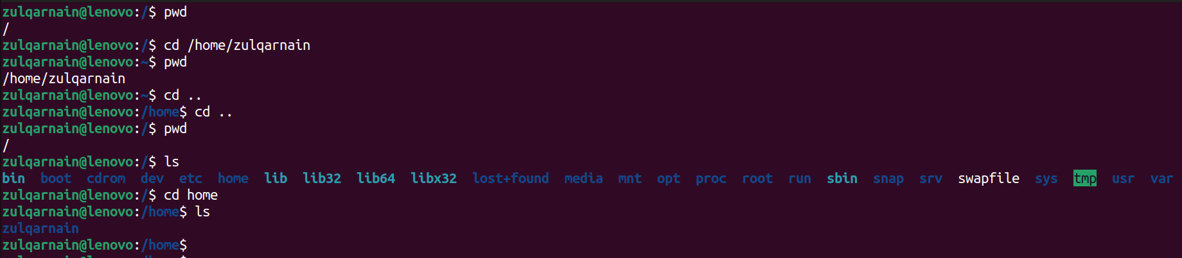
task:- 01

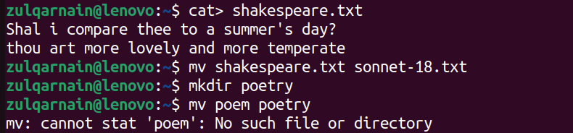
task:- 02

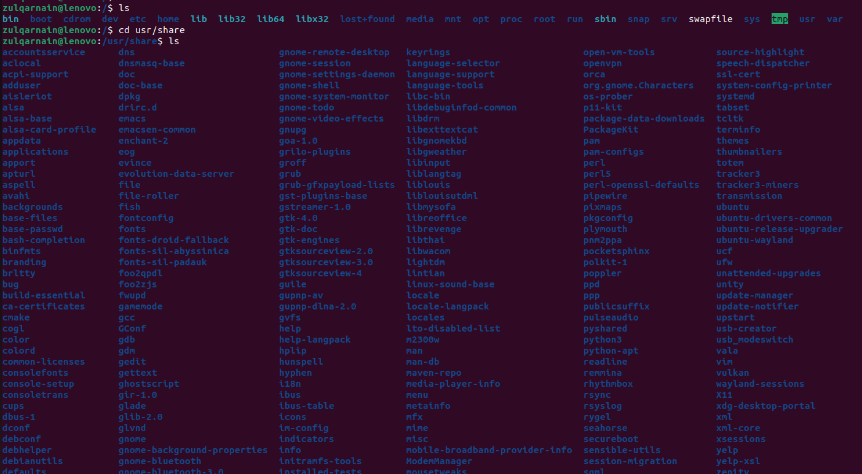
task:-3

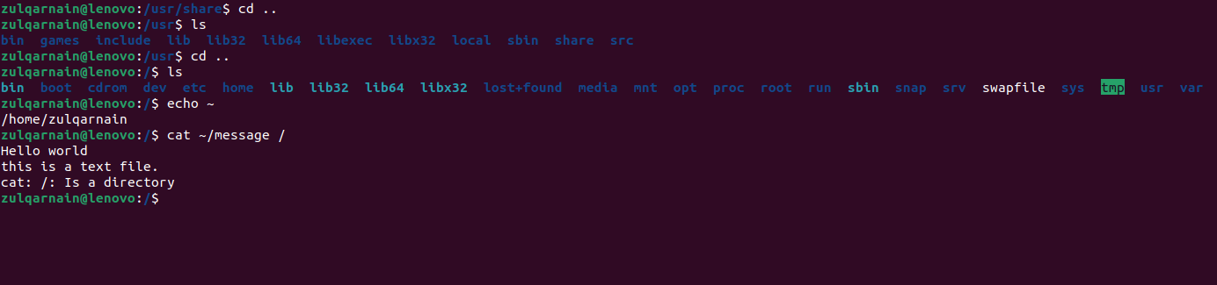

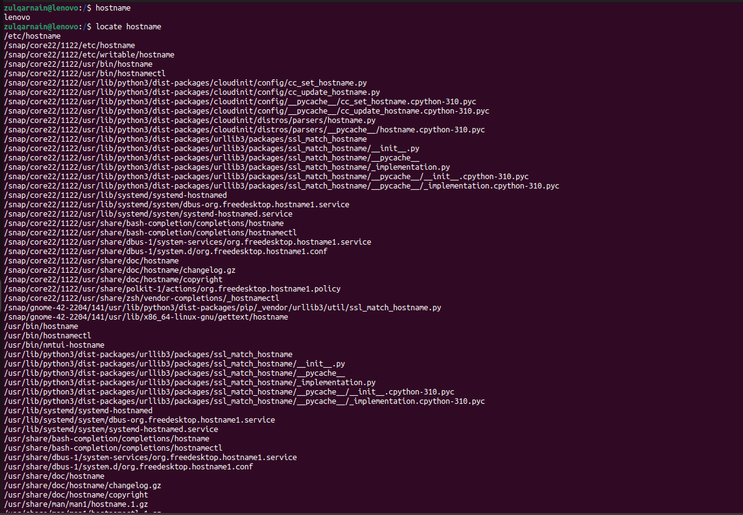
task:- 04
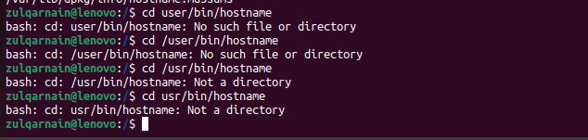

task:- 05
